

**Database Management System**

**(DBMS)**

# LABORATORY WORKBOOK

**Name: Muhammad Adnan**

**Roll No: 53448**

# LAB # 01

## The Purpose of this Lab is to get familiar with the File System & File Handling

### Exercise

**Question 1:**

What are the disadvantages of file processing system?

## Answer

**Disadvantages of File Processing System:**

**1)Redundancy:**

The same data can be present in two or more files which takes up more disc space.

**2)access time:**

Direct access of files is very difficult, and one needs to know the entire hierarchy of folders to get to a specific file. This involves a lot of time.

3)**Unorganized:**

Due to data redundancy, same data stored at different places might not match to each other.

**4)Data Integrity :**

The data present in the database should be consistent and correct. To achieve this, the data should satisfy certain constraints.

**5)recovery:**

Recovery or backup of lost and corrupt data is nearly impossible in case of File Processing System.

6)**No auto incrementation:**

Operations performed in the database must be atomic i.e. either the operation takes place as a whole or does not take place at all.

**7)Security:**

Anyone who gets access to the file can read or modify the data.

# LAB # 02

## The Purpose of this Lab is to get familiar with the Relational DBMS Architecture & its Concepts

**Exercise**

## Question 1

Modern School of higher education has around 2000 students and three departments. The students belong to various departments in the school. Every department has a Head of Department along with teachers.

The head of department manages his departmental teachers and the students belonging to his department. The head of department also teaches the students. All the head of departments report to the Principal of the school. The Principal manages the departments and also teaches the students. Handling the administrative staff of the school is also the responsibility of the Principal. Every individual, except the students, are the employees of the school

**Problem**

* Identify the entity
* Identify the entity’s attribute
* Identify the primary and foreign Keys
* Identify relationship between Entities
* Identify the Cardinality constraints

### Answer

1. **Entities:**

Students

Departments

Head of Departments

Teachers

Principal

Administrative Staff

1. **Entity Attributes:**

Students (Student_ID, Name, Phone_no, Address)

Departments (Department_ID, Name, E-mail)

Head of Departments (Name, E-mail)

Teachers (Teacher_ID, Name, Phone_no, Experience)

Principal (Name, Phone_no)

Administrative Staff (Name, Phone_no)

1. **Primary Key:**

Student_Id

Department_ID

Teacher-ID

1. **Relationship between Entities:**

* The relationship between Student and Department is Many to Many.
* The relationship between the Department and Head of Department is Many to Many.
* The relationship between the Head of Department and Teachers is One to Many.
* The relationship between the Head of Department and Students is One to Many.
* The relationship between the Principal and Department is One to Many.
* The relationship between Administrative Staff and Principal is One to One.

**ERD**

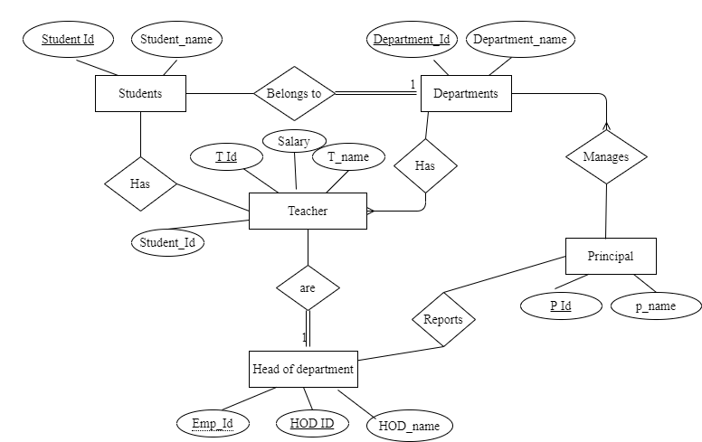

### Question 2

1. a professor teaches zero, one or many classes and a class is taught by one professor
2. a course may generate zero, one or many classes and a class comes from one course
3. a class is held in one room but a room has many classes

### Answer

1. A professor teaches zero, one or many classes and a class is taught by one professor



1. A course may generate zero, one or many classes and a class comes from one course



1. A class is held in one room but a room has many classes

Room

Class

## LAB # 03

**The Purpose of this Lab is to introduce Entity Relationship Diagram & its Notations**

**Exercise**

### Question 1

Modern School of higher education has around 2000 students and three departments. The students belong to various departments in the school. Every department has a Head of Department along with teachers.

The head of department manages his departmental teachers and the students belonging to his department. The head of department also teaches the students. All the head of departments report to the Principal of the school. The Principal manages the departments and also teaches the students. Handling the administrative staff of the school is also the responsibility of the Principal. Every individual, except the students, are the employees of the school

* Identify the entity
* Identify the entity’s attribute
* Identify the primary and foreign Keys
* Identify relationship between Entities
* Identify the Cardinality constraints
* Draw ERD

#### Answer

**1. Entities:**

* Students
* Departments
* Head of Departments
* Teachers
* Principal
* Administrative Staff

**2. Entity Attributes:**

* Students (Student_ID, Name, Phone_no, Address)
* Departments (Department_ID, Name, E-mail)
* Head of Departments (Name, E-mail)
* Teachers (Teacher_ID, Name, Phone_no, Experience)
* Principal (Name, Phone_no)
* Administrative Staff (Name, Phone_no)

**3. Primary Key:**

* Student_Id
* Department_ID
* Teacher-ID

**4. Relationship between Entities:**

* The relationship between Student and Department is Many to Many.
* The relationship between the Department and Head of Department is Many to Many.
* The relationship between the Head of Department and Teachers is One to Many.
* The relationship between the Head of Department and Students is One to Many.
* The relationship between the Principal and Department is One to Many.
* The relationship between Administrative Staff and Principal is One to One.

**5. ERD:**

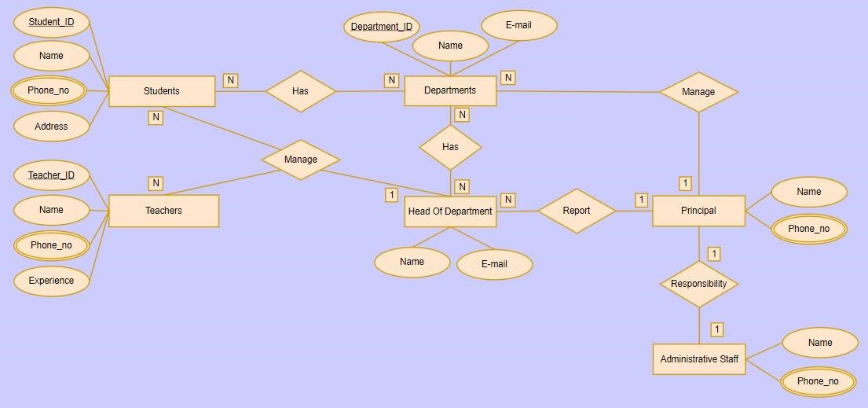

### Question 2

1. an invoice is written by one sales rep but a sales rep writes many invoices
2. a vendor sells many products but a product is bought from one vendor
3. an invoice has one or many products and a product is found on zero, one or many invoices
   * Identify the entity
   * Identify the entity’s attribute
   * Identify the primary and foreign Keys
   * Identify relationship between Entities
   * Identify the Cardinality constraints
   * Draw ERD

#### Answer

1. **Entities:**

* Invoice
* Sales_rep
* Vendor
* Product

1. **Entity Attributes:**

* Invoice (Invoice_no, Invoice_Product_ID, Invoice_Product_Quantity, Invoice_Date, Customer_Name, Customer_Address)
* Sales_rep (Sales_rep_ID, Sales_rep_Name, Sales_rep_Phone.no)
* Vendor (Vendor_ID, Name, Address, Phone.no)
* Product (Product_ID, Name, Sales_rep_ID, Vendor_ID)

1. **Primary Key:**

* Invoice_no
* Invoice_Product_ID
* Sales_rep_ID
* Vendor_ID
* Product_ID

**Foreign Key:**

* Sales_rep_ID
* Vendor_ID
* Product_ID

**4. Relationship between Entities:**

* The relationship between Invoice and Sales_rep is One to One.
* The relationship between Sales_rep and Invoices is One to Many.
* The relationship between Vendor and Products is One to Many.
* The relationship between Product and Vendor is One to One.
* The relationship between Invoice and Products is One to Many.
* The relationship between Product and Invoices is One to Many.

**ERD:**

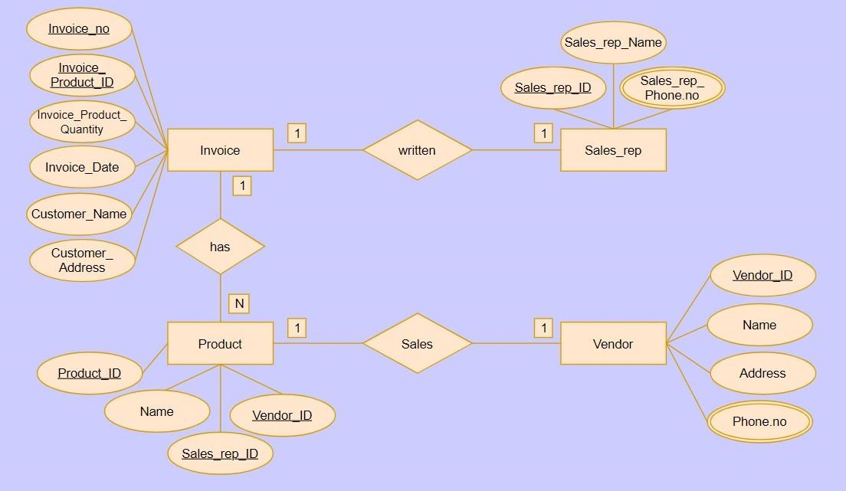

## 04

### The Purpose of this Lab is to make Entity Relationship Diagram by using Case Studies

**Exercise**

#### *CASE - STUDY -II*

The Prescriptions-R-X chain of pharmacies has offered to give you a free lifetime supply of medicine if you design its database. Given the rising cost of health care, you agree. Here’s the information that you gather:

* Patients are identified by an SSN, and their names, addresses, and ages must be recorded.
* Doctors are identified by an SSN. For each doctor, the name, specialty, and years of experience must be recorded.
* Each pharmaceutical company is identified by name and has a phone number.
* For each drug, the trade name and formula must be recorded. Each drug is sold by a given pharmaceutical company, and the trade name identifies a drug uniquely from among the products of that company. If a pharmaceutical company is deleted, you need not keep track of its products any longer.
* Each pharmacy has a name, address, and phone number.
* Every patient has a primary physician. Every doctor has at least one patient.
* Each pharmacy sells several drugs and has a price for each. A drug could be sold at several pharmacies, and the price could vary from one pharmacy to another.
* Doctors prescribe drugs for patients. A doctor could prescribe one or more drugs for several patients, and a patient could obtain prescriptions from several doctors.
* Each prescription has a date and a quantity associated with it. You can assume that, if a doctor prescribes the same drug for the same patient more than once, only the last such prescription needs to be stored.
* Pharmaceutical companies have long-term contracts with pharmacies. A pharmaceutical company can contract with several pharmacies, and a pharmacy can contract with several pharmaceutical companies. For each contract, you have to store a start date, an end date, and the text of the contract.
* Pharmacies appoint a supervisor for each contract. There must always be a supervisor for each Contract, but the contract supervisor can change over the lifetime of the contract.

Draw an ER diagram that captures the preceding information. Identify any constraints not captured by the ER diagram.

How would your design change if each drug must be sold at a fixed price by all pharmacies?

How would your design change if the design requirements change as follows: If a doctor prescribes the same drug for the same patient more than once, several such prescriptions may have to be stored?

### Answer

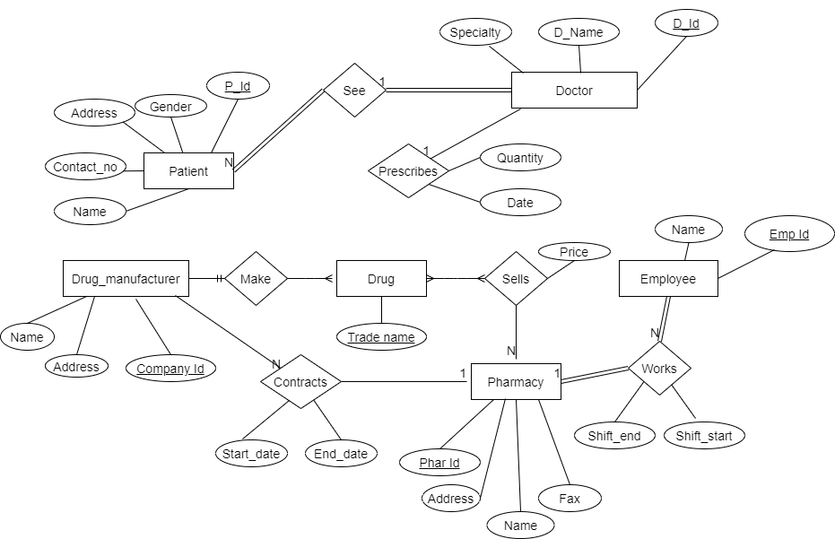

## 05

**The Purpose of this Lab is to introduce the DDL**

**(Data Definition Language) which includes Create, Drop, and Alter & Truncate Statements**

**Exercise**

### Question

Consider the following schema:

1. **Customer** (cust_id, cust_name).
2. **Product** (prod_code ,prod_name, unit_price)
3. **Customer_Order** (order_code, order_date, cust_id)
4. **Order_Item** (order_code, prod_code, num_of_units)

1. Develop DDL of in SQL

**Queries:**

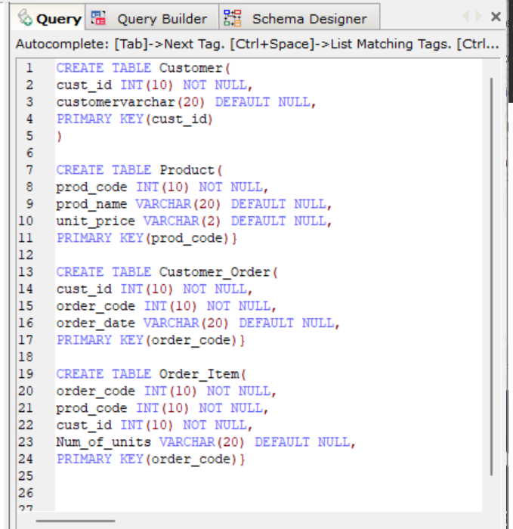

**Outputs:**

**1) Customer table:**

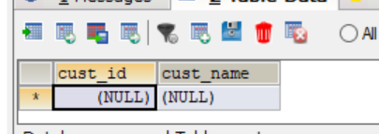

**2)Product table:**

3)**Customer_Order table :**

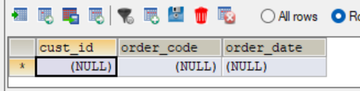

4)**Order_Item table:**

1. Add Column contact in Customer Table

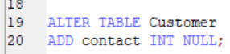

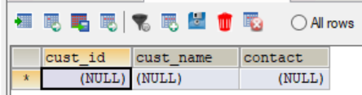

1. Add Column company_name in Product Table

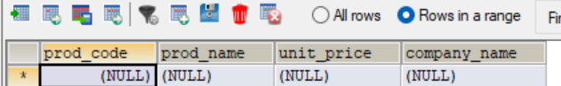

## 06

### The Purpose of this Lab is to introduce the DML

**(Data Manipulation Language) which includes Insert, Update & Delete Statements**

**Exercise**

### Question 1

Insert the following data into the following table

**Movie** (id, title, year, director)

|  |  |  |  |
| --- | --- | --- | --- |
|  |  |  |  |
| 1 | Ben hur | 2016 | Thomas |
| 2 | Get Smart | 2012 | Richard Bell |
| 3 | Spider Man | 2009 | Tam Morry |
| 4 | Batman V/S Super Man | 2015 | Gerald Hond |

#### Id Title Year Director

#### Answer

